Execute the following Queries by SQL COMMANDS
- Show all data associated in salgrade table
- Show deptno from dept table
- Show 5% increment of salary from emp table for each of the employee (ENAME, SALARY, 5% INCREMENT)
- Show the new salary after increment (from 3) for each of the employee in emp table
- Show all the associated information of the employee named “BLAKE”.
- Run the SQL COMMAND to show the following output
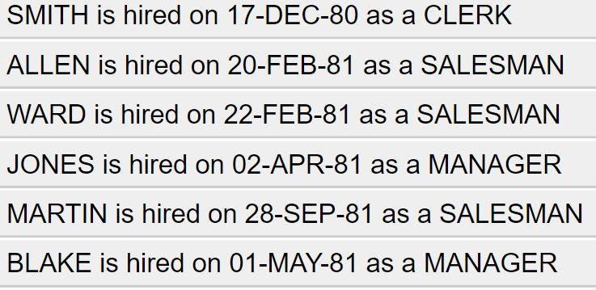
- Show the description of all the four tables in the scott schema
- Show all the possible jobs from the emp table eliminating the duplicate instances or output

